1.**Ajax**-валидация введенного **email**:

**app\Http\Requests\SubstribeRequest.php**

class ***Substribe***Request extends Request

{

public $validator = null; //if you need validator->errors() in Controller

protected function failedValidation(\Illuminate\Contracts\Validation\Validator $validator) //if you need validator->errors() in Controller

{

$this->validator = $validator;

}

/**

* Get the validation rules that apply to the request.

*

* @return array

*/

public function rules()

{

return $rules = [

**'email' => 'bail|email',**

];

}

}

**app\Http\Controllers\ShopController.php**

use App\ {

…

**Http\Requests\SubstribeRequest**

};

…

public function **mailer(SubstribeRequest $request**, ShopRepository $repository)

{

**if(isset($request->validator) && $request->validator->fails()) //if you need validator->errors() in Controller**

**{**

**return json_encode($request->validator->errors());**

**}**

return $repository->mailer($request);

}

**public\js\main.js**

**mailer**: function(value){

…

success: function(data){

//alert(data.answer); **//!!!data.answer - {"mail":[true],"request":[true]}**

//alert(data); **//!!!data -** {"email":["The email must be a valid email address."]}

**if(data.answer) {**

**var data_json=JSON.parse(data.answer);**

**if(data_json['mail']) alert('We sent the message to your email!');**

**} else {**

**var data_json=JSON.parse(data);**

**var error_str='';**

**for(var i in data_json){**

**error_str+=data_json[i]+'\n';**

**}**

**alert(error_str);**

**}**

},

};

$.ajax(ajaxSetting);

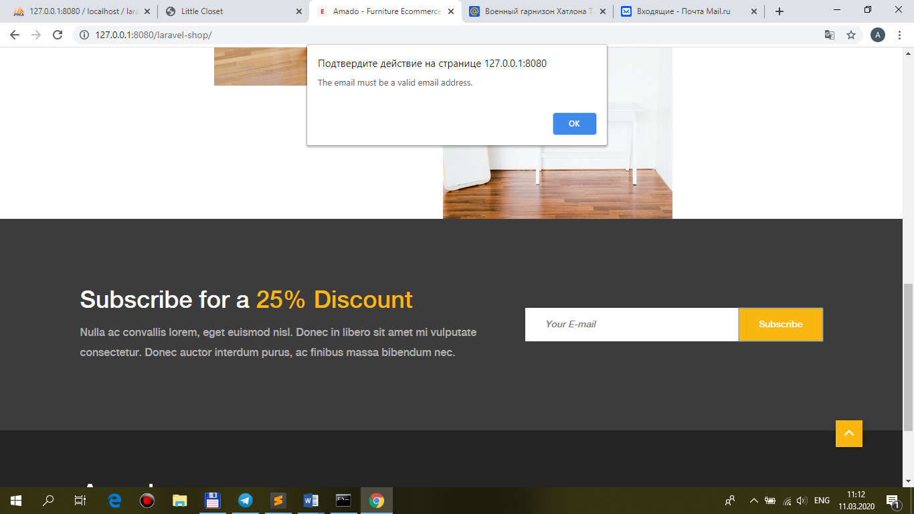

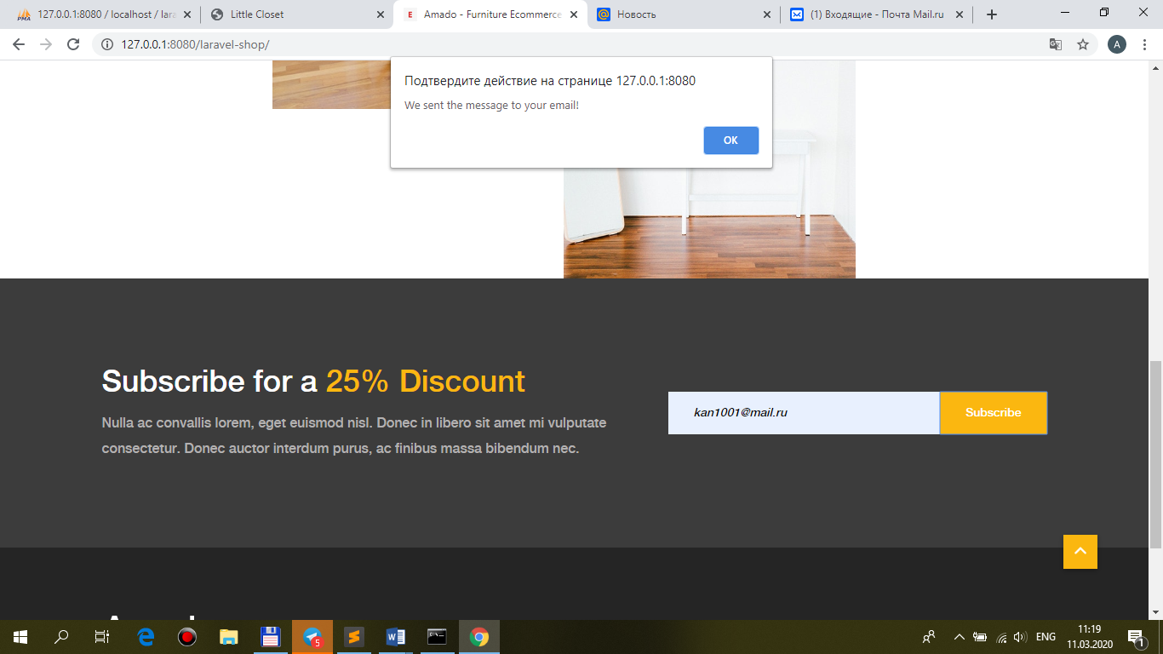

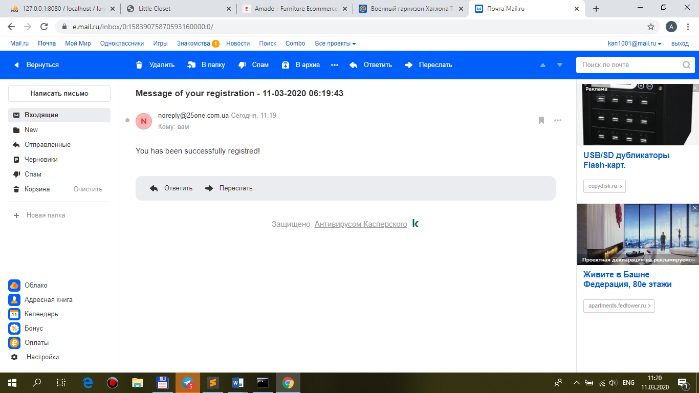

2.Запись **email**-регистрации в **БД**:

**database\migrations\2019_02_04_082606_substribes.php**

class **Substribes** extends Migration

{

/**

* Run the migrations.

*

* @return void

*/

public function up()

{

Schema::create(**'substribes'**, function (Blueprint $table) {

**$table->increments('id');**

**$table->string('email');**

});

}

/**

* Reverse the migrations.

*

* @return void

*/

public function down()

{

Schema::dropIfExists(**'substribes'**);

}

}

**php artisan migrate**

**app\Models\Substribe.php**

class **Substribe** extends Model {

public $timestamps = false;

**protected $fillable = [**

**'email'**

**];**

}

**app\Repositories\ShopRepository.php**

use App\Models\ {

Product,

Cart,

**Substribe**

};

…

public function **mailer($request)**

**{**

**Substribe::create($request->all());**

…

